**HEART RISK ASSESSMENT REPORT**

Project report in partial fulfillment of the requirement of Innovative Project

In

Department of Computer Science and Engineering

Submitted By

**DIPTESH MONDAL**  Department of Computer Science,

University Enrollment No. 12023002001308 UEM, Kolkata

Section: B, Class Roll No.: 24



UNIVERSITY OF ENGINEERING & MANAGEMENT, KOLKATA

University Area, Plot No. III – B/5, New Town, Action Area – III, Kolkata – 700160.

**CERTIFICATE**

This is to certify that the project report entitled “**Heart Risk Assessment**” has been carried out by Diptesh Mondal (University Roll No. 12023002001334), student of the Department of Computer Science and Engineering at the University of Engineering & Management, Kolkata.

The work presented in this report is the original contribution of mine and has been carried out with the utmost dedication and adherence to academic standards. I have successfully completed the tasks outlined for this project, which involved understanding, designing, and implementing heart risk assessment to assist users for product showcase and enhancing productivity.

The project work embodies extensive research, analysis, and application of software design principles relevant to computer science and engineering, particularly in web development and user interface design. Through this project, I have demonstrated their ability to integrate technical knowledge with practical skills, producing a functional website designed data analysis, patient history evaluations, and modern risk calculation methods

This certificate is issued in recognition of their hard work, innovative approach, and commitment to academic excellence. The project is a testament to my proficiency in tackling real-world challenges and applying the knowledge acquired during their coursework.

The content of this project has not been submitted, in whole or in part, for any other degree, diploma, or examination at this or any other institution.

_______________________________ _________________________________

Signature of Project Guide Signature of Head of the Department

**ACKNOWLEDGEMENT**

I would like to express my deepest gratitude to everyone who provided support and encouragement throughout this project. Completing this project successfully has been an enriching journey, filled with learning experiences that I could not have achieved before. My heartfelt thanks goes to the University of Engineering & Management, Kolkata, and the Department of Computer Science and Engineering for providing me with an environment conducive to academic growth. The resources, infrastructure, and technical support offered by the university played an essential role in helping me to bring this project to completion. I am grateful to my fellow classmates and peers who shared their ideas, insights, and encouragement throughout this process. Engaging in discussions with them helped refine my understanding and led me to innovative approaches and solutions.

I also extend my sincere thanks to my family, whose unwavering support and encouragement inspired me to keep pushing forward, even when the project’s demands were challenging. Their patience and understanding gave me the strength to persevere through long hours of work, testing, and troubleshooting. Finally, I acknowledge the learning opportunities that this project presented, which enabled me to grow in technical expertise, collaboration, and problem-solving skills. This project has been a significant milestone in mine academic journey, and I am grateful to everyone who contributed to making it a fulfilling and successful experience. Thank you to all who made this project possible.

Diptesh Mondal

Table of Contents

Table of Contents

1. Introduction  
   1.1 Purpose  
   1.2 Intended Audience and Reading Suggestions  
   1.3 Project Scope  
   1.4 References
2. Overall Description  
   2.1 Background on Heart Risk Factors  
   2.2 Key Indicators of Heart Risk  
   2.3 Assessment Methods and Tools  
   2.4 Research Constraints and Limitations
3. System Features  
   3.1 Heart Risk Assessment Procedure  
   3.2 Data Collection and Interpretation  
   3.3 Risk Factor Categorization
4. External Interface Requirements
5. Preventative Measures
6. Other Health Considerations
7. Design Documents
   * Appendix A: Glossary
   * Appendix B: Implementation
   * Appendix C: Testing
8. Screenshots of the Developed System
9. Future Scope  
   9.1 Homepage Enhancements  
   9.2 Enhanced User Authentication System  
   9.3 Admin Dashboard Features  
   9.4 Patient Dashboard Enhancements  
   9.5 Healthcare Provider Dashboard Improvements  
   9.6 Security and Data Protection Enhancements  
   9.7 Technology Stack Upgrades  
   9.8 Future Scalability Considerations  
   9.9 User Training and Support
10. Bibliography

# 1. INTRODUCTION

# 1.1 Purpose

* The purpose of Heart Risk Assessment is to assess the risk factors associated with heart disease and provide preventative recommendations based on scientific research and data analysis.

# 1.2 Intended Audience and Reading Suggestions

* This report is intended for healthcare professionals, researchers, and individuals interested in understanding heart risk assessment and preventative measures

**1.3 Project Scope**

* The assessment covers risk factors such as cholesterol levels, blood pressure, lifestyle habits, genetic predisposition, and stress levels. It utilizes various medical tools and statistical analysis to determine individual heart risk.

**1.4 References**

* W3Schools – Python, HTML, CSS, JavaScript, MDN Web Docs, CSS-Tricks.

**2. OVERALL DESCRIPTION**

**2.1 Background on Heart Risk Factors**

* Heart disease remains one of the leading causes of death worldwide. Major contributing factors include poor diet, lack of physical activity, smoking, and hereditary conditions**.**

**2.2 Key Indicators of Heart Risk**

* Blood Pressure Levels
* Cholesterol and Triglyceride Levels
* Body Mass Index (BMI)
* Family History of Heart Disease
* Lifestyle Choices (Smoking, Alcohol, Diet, Exercise)

**2.3 Assessment Methods and Tools**

* Electrocardiogram (ECG)
* Blood Tests (Lipid Profile, Sugar Levels)
* Heart Rate Monitoring
* Stress Test Evaluations
* Imaging Tests (Echocardiogram, MRI, CTScan)

**2.4 Research Constraints and Limitations**

* Due to the individualized nature of heart risks, not all contributing factors may be accurately quantified in every assessment. External variables such as stress levels and environmental factors can also influence heart health.

**3. SYSTEM FEATURES**

**3.1 Heart Risk Assessment Procedure**

1. Collection of Patient History and Lifestyle Information.
2. Medical Tests and Examinations.
3. Risk Categorization (Low, Moderate, High Risk).
4. Personalized Preventative Recommendations.

**3.2 Data Collection and Interpretation**

* Data is collected through patient interviews, medical records, and clinical tests. It is then interpreted using risk models such as the **Framingham Heart Study Risk Score** and **QRISK3 Model**.

**3.3 Risk Factor Categorization**

|  |  |
| --- | --- |
| **Risk Level** | **Indicators** |
| Low Risk | Normal BP, Low Cholesterol, Active Lifestyle |
| Moderate Risk | Borderline BP, Slightly Elevated Cholesterol, Inconsistent Exercise |
| High Risk | Hypertension, Obesity, Smoking, Family History of Heart Disease |

**4. External Interface Requirements**

* **Genetic Factors**
* **Environmental Pollution**
* **Workplace Stress**
* **Socioeconomic Status and Access to Healthcare**

**5. PREVENTATIVE MEASURES**

* Balanced Diet (Rich in Fruits, Vegetables, and Whole Grains)
* Regular Exercise (Minimum 30 Minutes Daily)
* Smoking and Alcohol Cessation
* Stress Management Techniques (Meditation, Therapy)
* Regular Health Checkups

### **6. OTHER HEALTH CONSIDERATIONS**

* Heart risk factors often overlap with conditions like **diabetes, obesity, and hypertension**, requiring an integrated approach to prevention and management.

**7. Design Documents**

**Appendix A: Glossary**

* **Heart Risk Assessment Tool**: A digital system that helps evaluate an individual’s likelihood of developing heart disease based on various health indicators.
* **Patient:** A person undergoing a heart risk evaluation to understand their cardiovascular health status.
* **Automated Risk Analysis:** A feature that calculates heart risk scores automatically based on input data such as blood pressure, cholesterol levels, and lifestyle habits.
* **Diagnostic Indicators:** Key health metrics such as ECG results, blood test reports, and BMI that contribute to heart risk assessment.
* **Responsive Health Monitoring:** A system that ensures heart health data is accessible and adaptable across multiple devices, including mobile and desktop platforms.
* **Risk Visualization Tools:** Graphical representations such as charts and graphs that help illustrate heart risk levels and trends over time.
* **Medical Integration:** The ability to link the risk assessment tool with electronic health records and hospital databases for comprehensive patient monitoring.
* **Customizable Analysis:** The option to adjust parameters like age, weight, medical history, and lifestyle choices to tailor heart risk evaluation for different individuals.
* **Performance Optimization:** Techniques used to ensure fast and accurate risk calculation while maintaining smooth user interaction.

**Appendix B: Implementation**

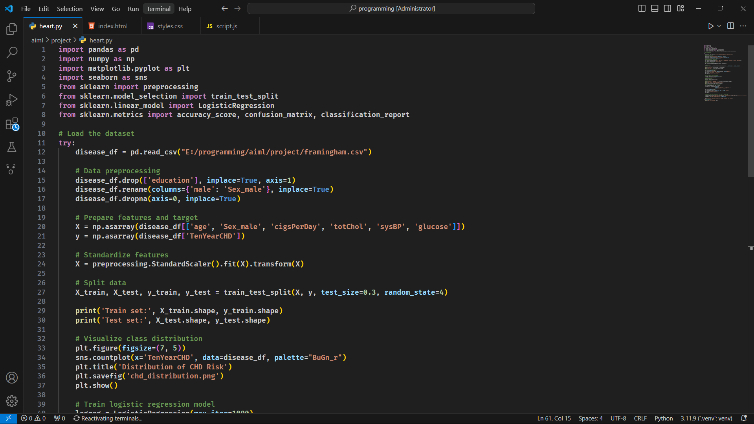

*PYTHON CODE*

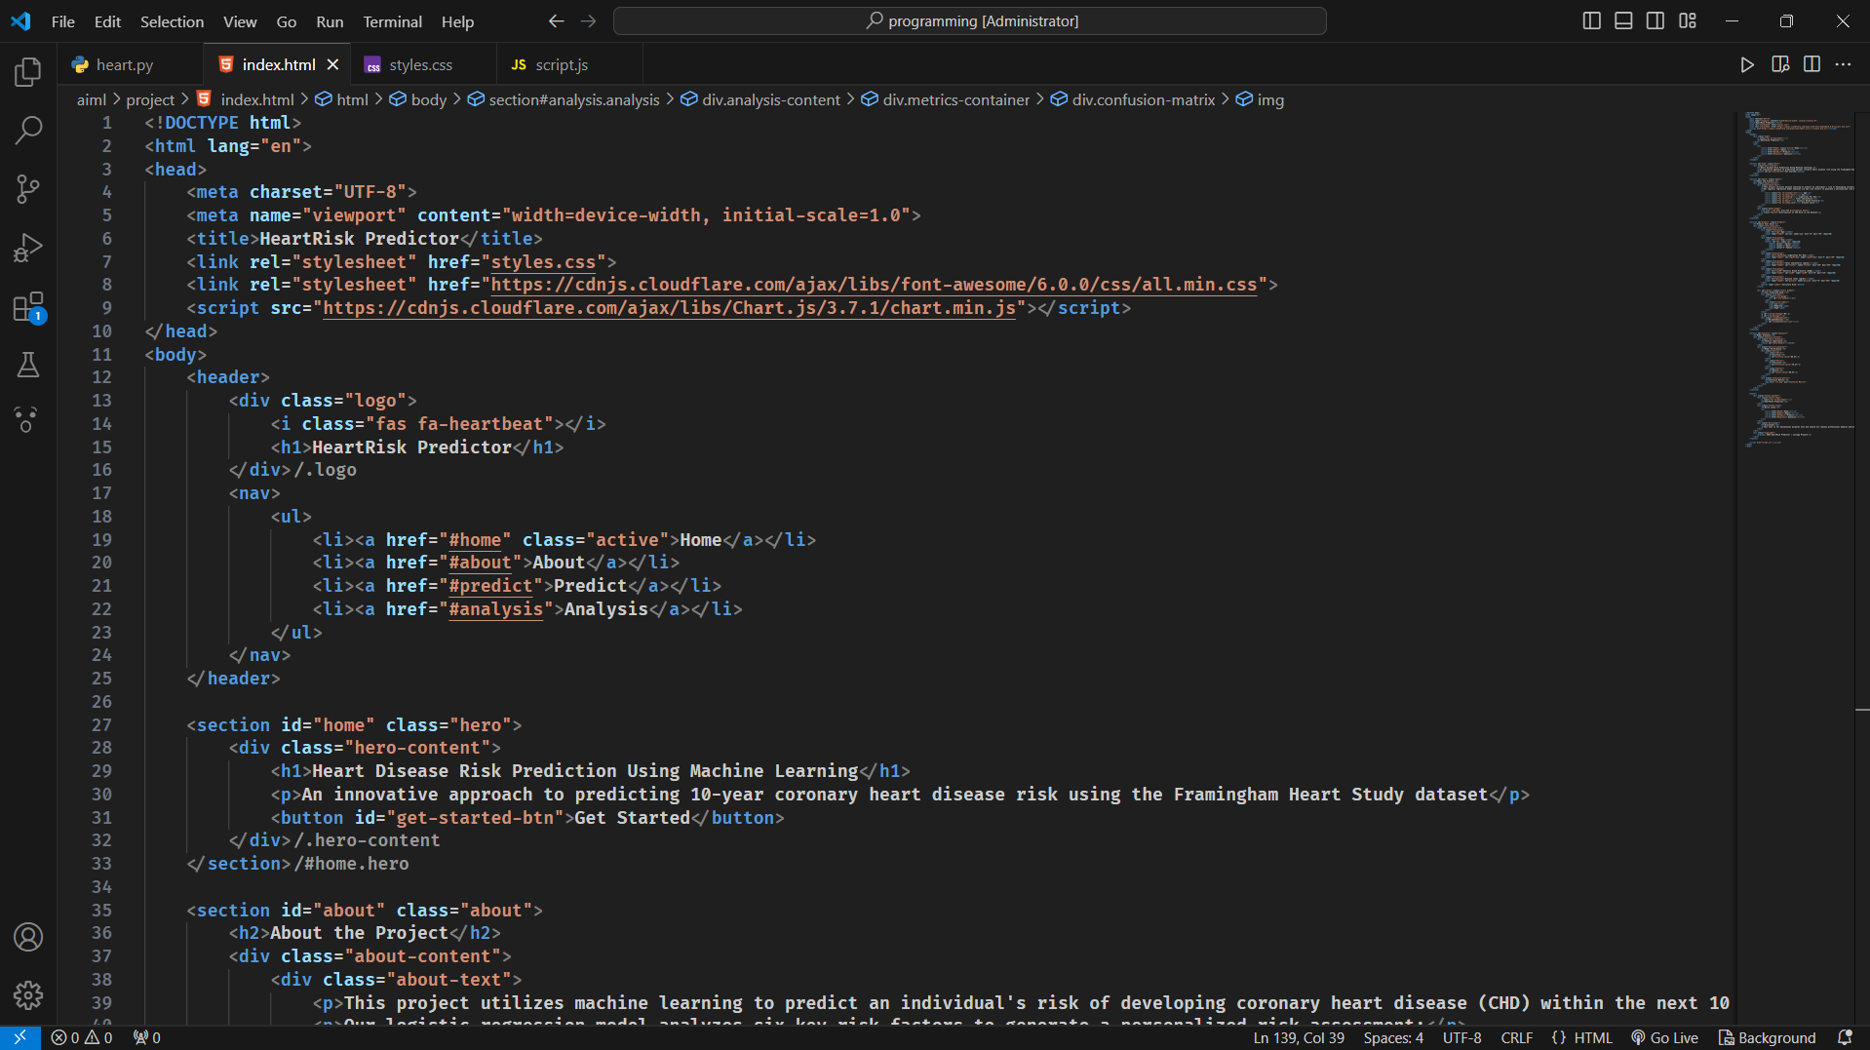

*HTML WEB PAGE*

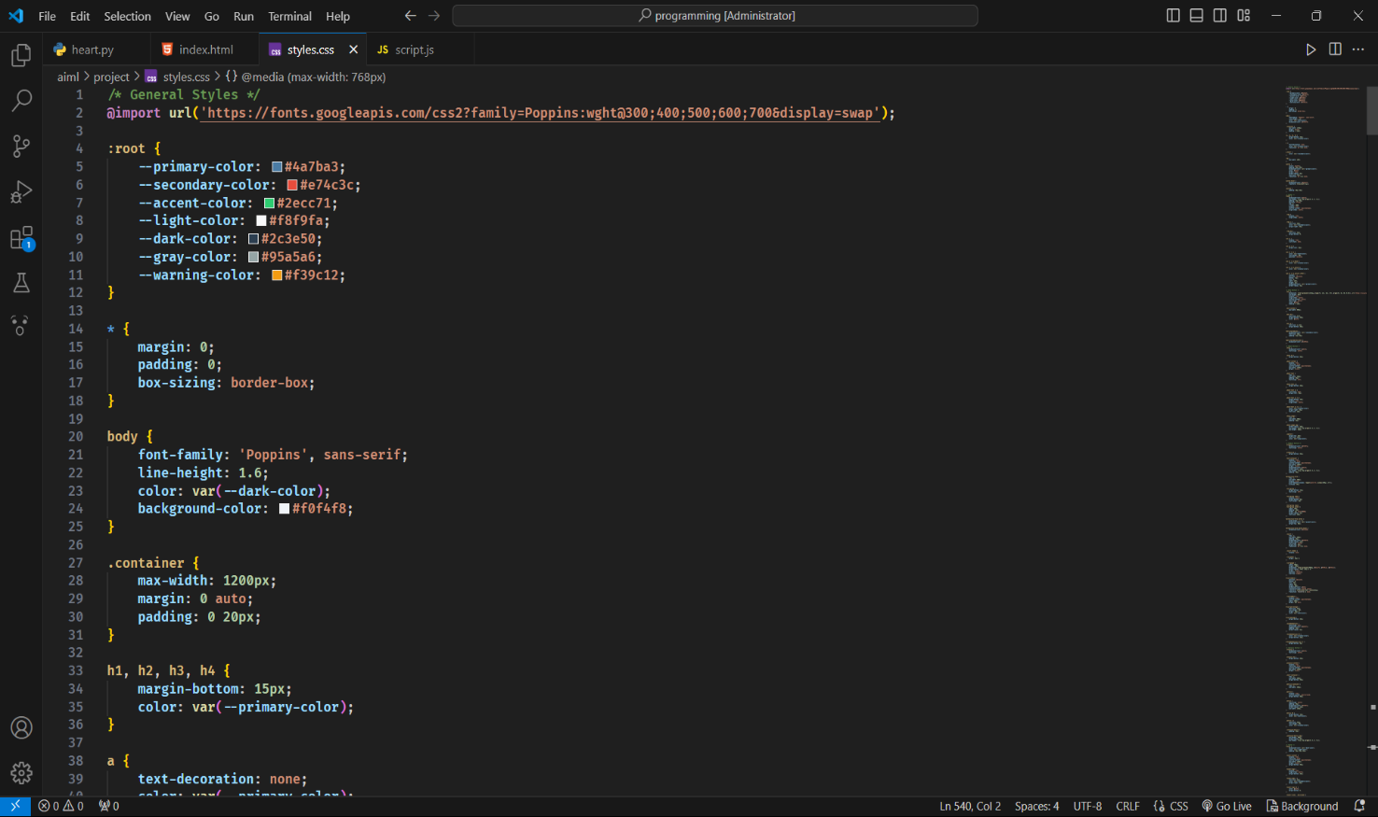

*STYLING PAGE*

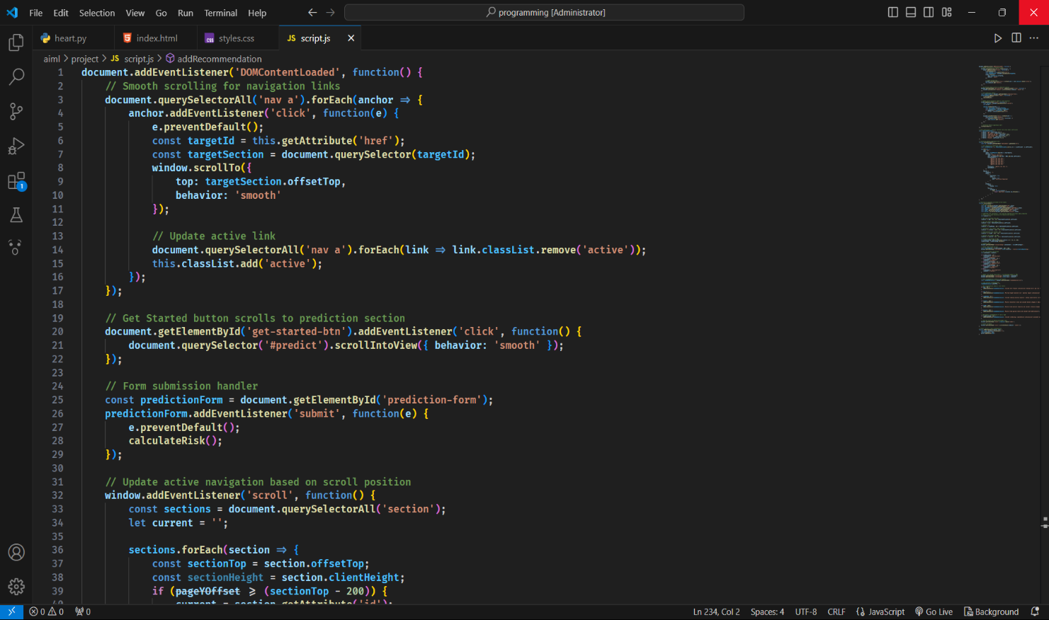

*FUNCTIONALITY PAGE*

**Appendix C: Testing**

**1. Risk Assessment Navigation Tests**

* Verify that the heart risk assessment tool smoothly transitions between different risk factors and assessment steps.
* Ensure that users can navigate between different sections (e.g., patient history, test results, recommendations) without errors.

**2. Responsive Design Tests**

* Confirm that the heart risk assessment tool adapts correctly to different screen sizes (desktop, tablet, mobile).
* Test on various browsers (Chrome, Firefox, Edge, Safari) to ensure full functionality and compatibility.

**3. Analysis and Performance Tests**

* Verify that risk calculation models (Framingham Score, QRISK3) function accurately without errors or slowdowns.
* Ensure that all data visualizations (charts, graphs) load quickly and display properly.

**4. User Interaction Tests**

* Test manual data input to confirm that users can enter their medical information without issues.
* Ensure that users receive clear feedback on their risk levels and next steps.

**5. Integration and Display Tests**

* Verify that the tool can be integrated into different medical platforms without conflicts.
* Ensure that test results, patient details, and recommendations display correctly across different devices.

**8. Screenshot of the Developed System**

*HOME PAGE AND ABOUT PAGE*

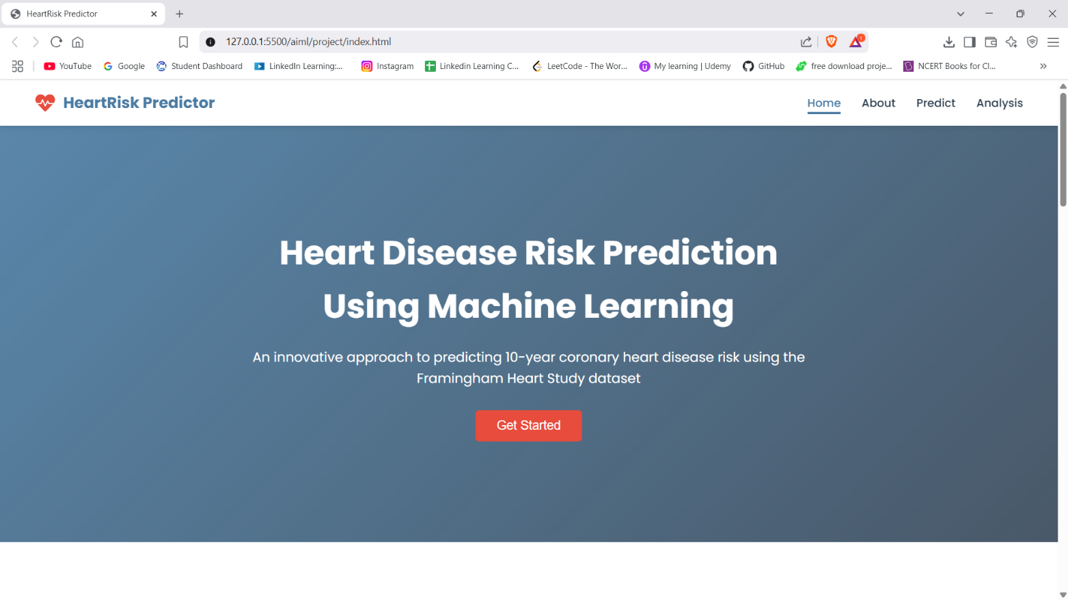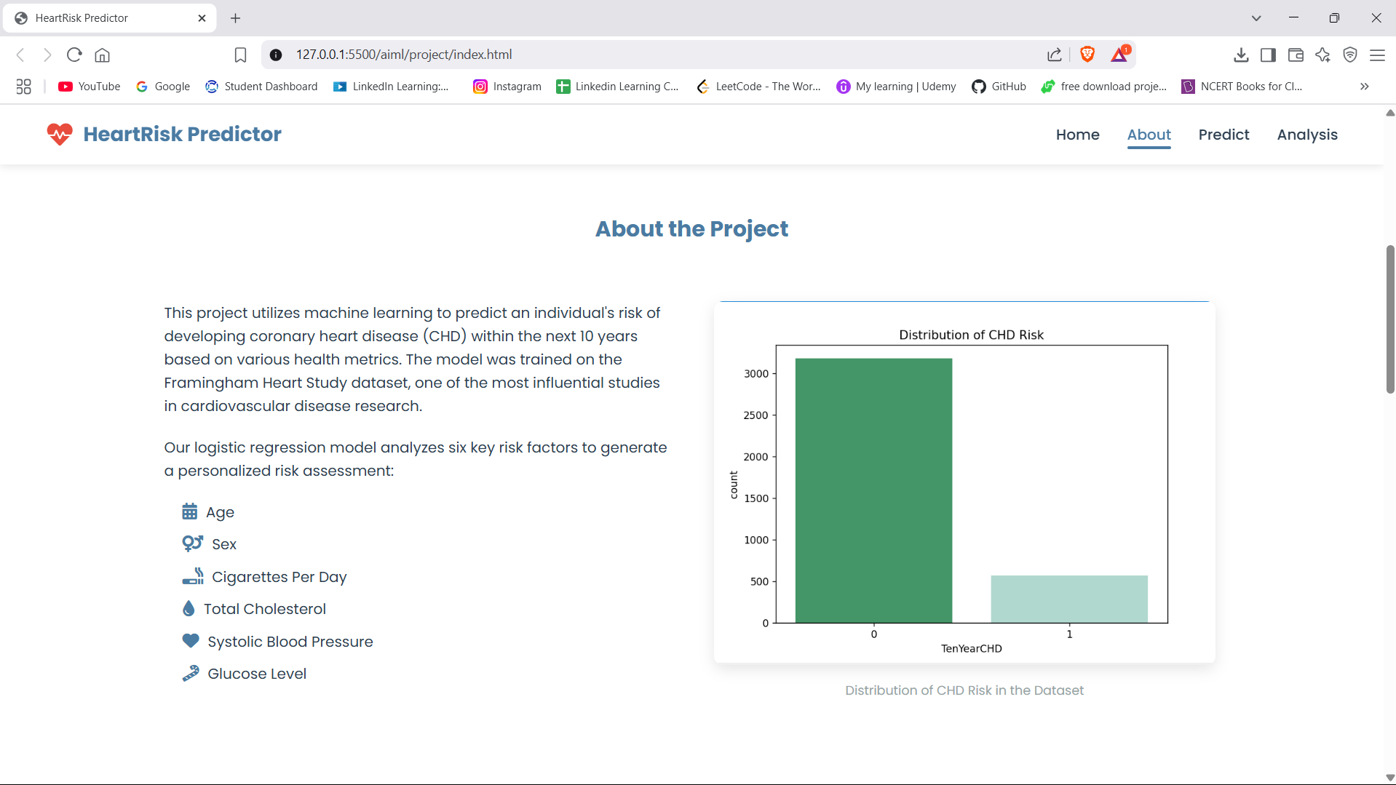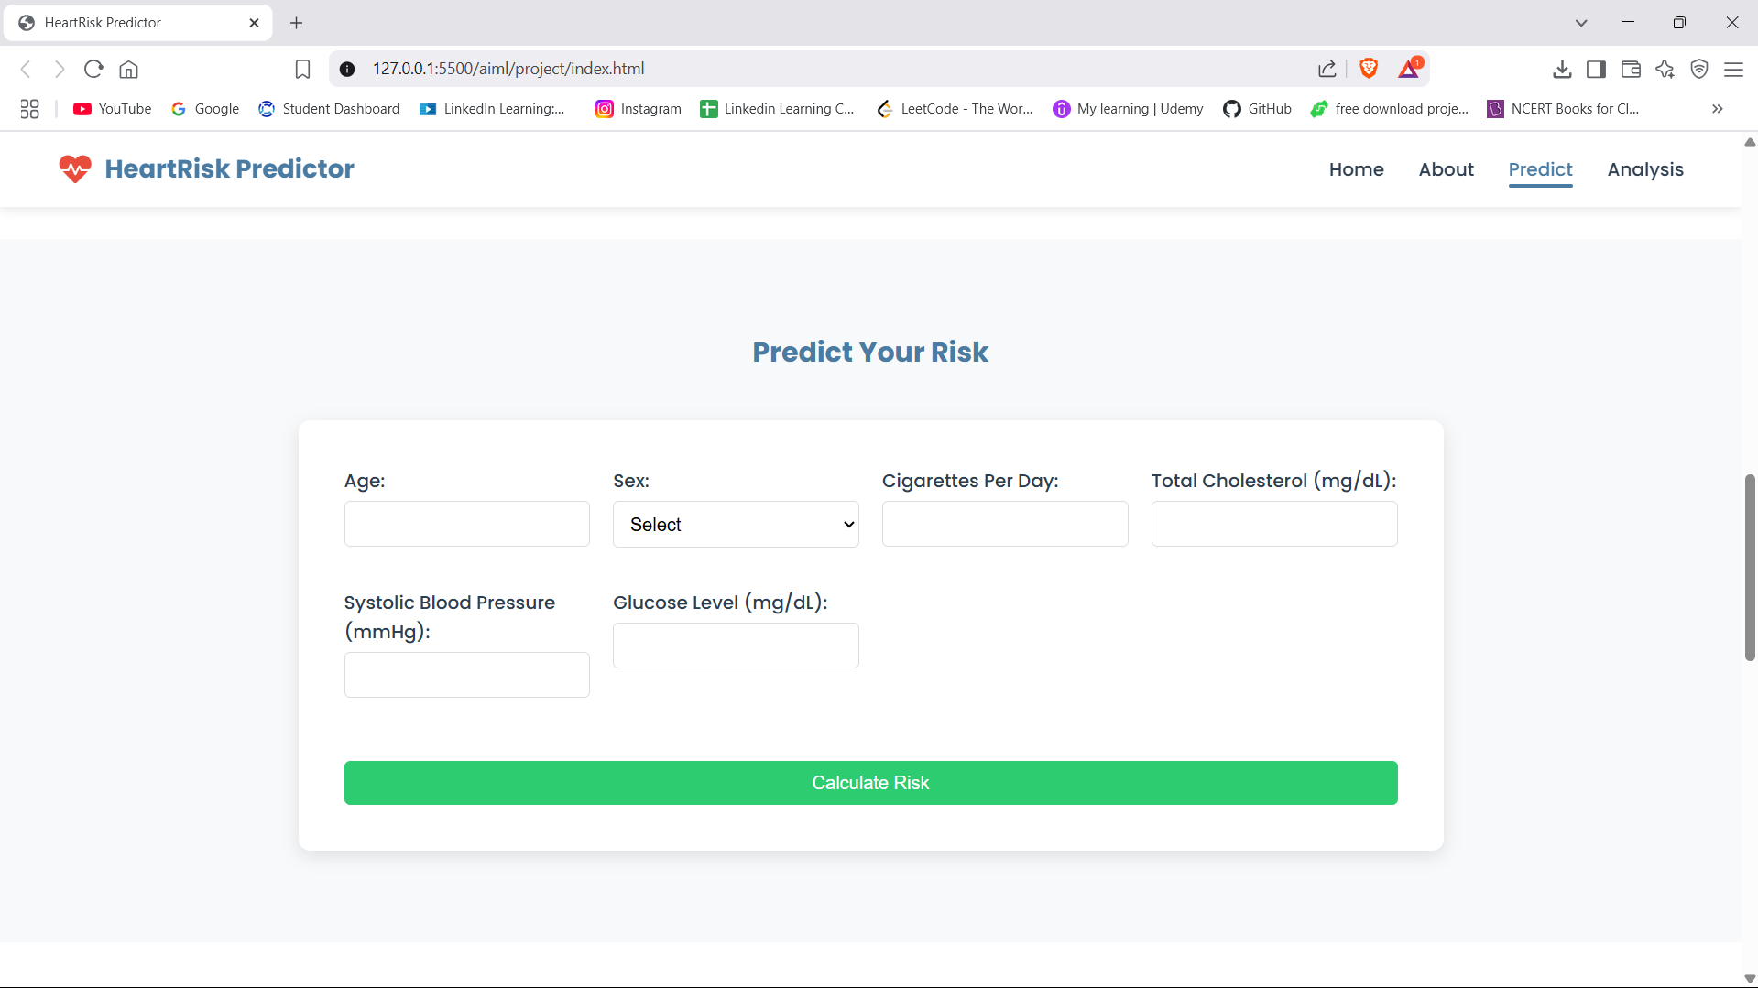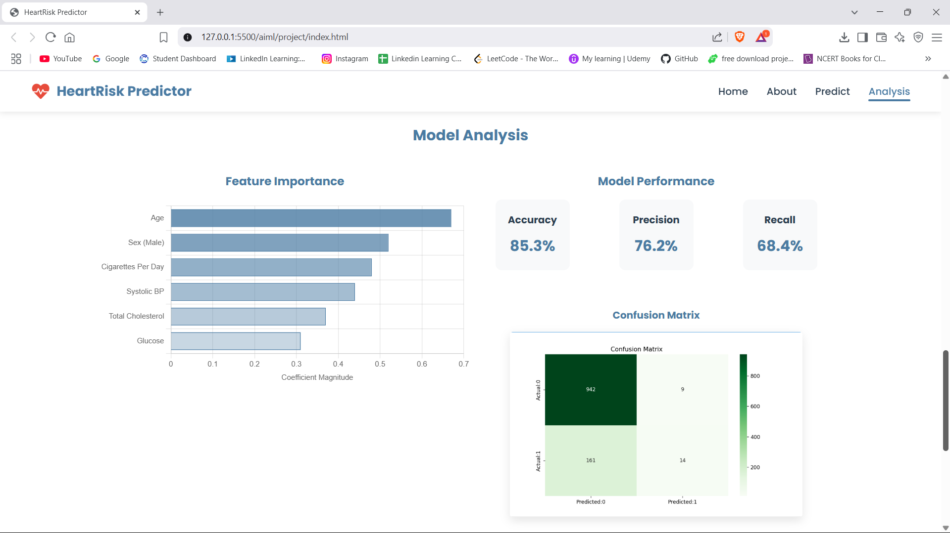

*RISK PREDICTION PAGE AND ANALYSIS PAGE*

**9. Future Scope**

**1. Homepage Enhancements**

* **User-Friendly Interface**: Improve the homepage layout for seamless navigation and better user experience in heart risk assessment.
* **Dynamic Health Alerts**: Implement a real-time notification system for critical health alerts (e.g., high-risk assessments, urgent checkups).
* **Personalized Notifications**: Introduce email and in-app alerts for upcoming health checkups, report availability, and preventive care reminders.

**2. Enhanced User Authentication System**

* **Multi-Factor Authentication (MFA)**: Strengthen security by requiring additional verification during login.
* **User Profile Management**: Allow users to update their medical history, lifestyle details, and emergency contacts.
* **Secure Login & Lockout Mechanism**: Prevent unauthorized access by locking accounts after multiple failed login attempts.

**3. Admin Dashboard Features**

* **Advanced Data Analytics**: Integrate analytics tools to monitor heart risk trends, patient history, and assessment results.
* **Customizable Risk Reports**: Enable administrators to generate detailed health reports based on various parameters (age, lifestyle, genetics).
* **Audit Logs for Accountability**: Track changes to patient records and assessment results for transparency.

**4. Patient Dashboard Enhancements**

* **Personalized Health Reminders**: Allow users to set reminders for health checkups, medication schedules, and lifestyle improvements.
* **Feedback & Consultation Requests**: Implement a system for patients to provide feedback on assessments and request virtual consultations.
* **Mobile Compatibility**: Ensure a responsive, mobile-friendly interface for easy access to health reports on smartphones and tablets.

**5. Healthcare Provider Dashboard Improvements**

* **Patient Assessment Management**: Enable doctors and healthcare professionals to review heart risk assessments efficiently.
* **Incident Reporting Tools**: Provide healthcare providers with reporting tools for tracking emergency cases or incorrect assessments.

**6. Security and Data Protection Enhancements**

* **Data Encryption**: Apply end-to-end encryption to protect patient records and sensitive health data.
* **Regular Security Audits**: Conduct periodic security assessments to ensure compliance and protect against vulnerabilities.
* **HIPAA/GDPR Compliance**: Ensure strict adherence to global data protection regulations for secure patient information handling.

**7. Technology Stack Upgrades**

* **Modern Frontend Frameworks**: Utilize frameworks like React or Vue.js for an interactive and user-friendly health dashboard.
* **Optimized Backend Frameworks**: Use Laravel or Node.js for improved performance and scalability.
* **Cloud Integration**: Leverage AWS or Azure for secure and scalable data storage and management.

**8. Future Scalability Considerations**

* **AI-Based Risk Prediction**: Implement AI-driven models to improve heart risk prediction accuracy.
* **API Integration**: Develop APIs for seamless integration with hospital databases and wearable health devices.
* **Automated Data Backup & Recovery**: Ensure secure data migration and backup strategies for system reliability.

**9. User Training and Support**

* **Comprehensive User Guides**: Provide detailed manuals for patients, doctors, and administrators.
* **Training Webinars**: Organize training sessions to help users navigate health assessment tools effectively.
* **24/7 Support System**: Implement a helpdesk and ticketing system for users to report issues and request assistance.

**10.Bibliography**

* Duckett, Jon. HTML and CSS: Design and Build Websites. Wiley, 2011.
* Flanagan, David. JavaScript: The Definitive Guide. O'Reilly Media, 2020.